**Node Todo CICD**

**By Shubham**

**Using Kubernetes, docker and NPM (node package manager)**

**First with Kubernetes**

* Create two EC2 AWS Ubuntu instances, one master and the other as a worker. (master instance type will be medium)
* Git clone <https://github.com/ssupshub/Kubernetes-file-.git> for configuration and connect.

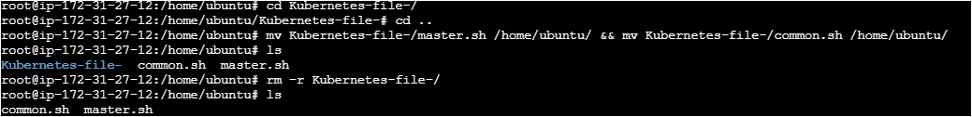

* Remove master file in worker server
* Chmod +x master.sh common.sh
* ./common.sh (in both instance) and ./master.sh (only in master server)
* After execute ./master, you will obtain a kubeadm token. Paste it on the worker server to connect to the master server.



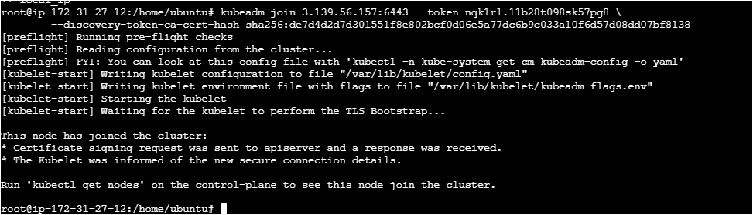

* Verify the connection in master server.
* Run kubectl get nodes

* Git clone <https://github.com/LondheShubham153/node-todo-cicd.git>
* Cd node-todo-cicd/k8s
* Create the Namespace (kubectl create namespace node-app)
* Check for the Namespace (kubectl get namespaces)

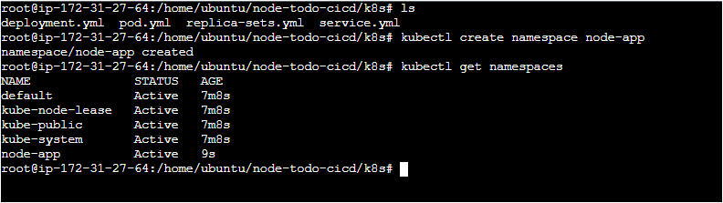

* Build the project:

1. kubectl apply -f deployment.yml
2. kubectl apply -f service.yml
3. kubectl apply -f replica-sets.yml
4. kubectl apply -f pod.yml

* Verify Resource Creation (kubectl get all -n node-app)

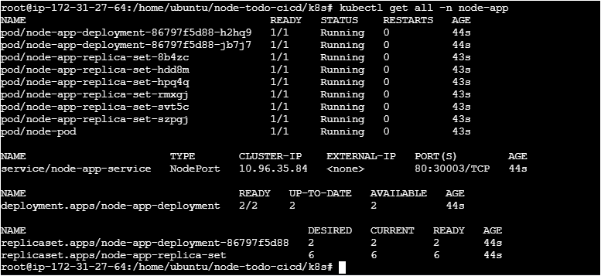

* Project build successfully, now copy and paste the master instance public IP in new tab with :30003.

**Now with docker**

* Launch EC2 AWS Ubuntu Instance.
* Choose micro as an instance type.
* Security group choose all traffic.
* After launch your instance, connected via SSH service
* Apt update && apt upgrade -y
* Apt install docker.io -y (install docker)
* Docker –version (verify installation)
* systemctl start docker && systemctl enable docker
* for install docker compose

1. sudo curl -L "https://github.com/docker/compose/releases/download/v2.20.0/docker-compose-$(uname -s)-$(uname -m)" -o /usr/local/bin/docker-compose
2. sudo chmod +x /usr/local/bin/docker-compose
3. docker-compose –version

* git clone <https://github.com/LondheShubham153/node-todo-cicd.git>
* cd node-todo-cicd
* docker-compose build (build the project)
* docker-compose up

* Docker-compose build use docker-compose file to build the project
* Now Project build successfully, now copy and paste the master instance public IP in new tab with :30003.

* Use (Docker-compose down) to shutdown the project or temporary stop the project.

**Lastly with NPM (Node Package Manager)**

* Launch EC2 AWS Ubuntu Instance.
* Choose micro as an instance type.
* Security group choose all traffic.
* After launch your instance, connected via SSH service
* apt update && apt upgrade -y
* curl -fsSL https://deb.nodesource.com/setup_18.x | sudo -E bash -
* sudo apt install -y nodejs
* node -v
* npm -v
* git clone <https://github.com/LondheShubham153/node-todo-cicd.git>
* cd node-todo-cicd
* npm install
* npm update
* npm audit fix –force
* npm start

